FOR IMMEDIATE RELEASE – July 25, 2011
Contact: Gentle Thunder - (530) 925-4495 / GT@GentleThunder.com

CRAIG CHAQUICO & GENTLE THUNDER OFFER BENEFIT CONCERT

Ashland, OR - The State of Jefferson’s very own GRAMMY® nominated recording artists, Craig Chaquico (former guitarist of Jefferson Starship/Starship) and Gentle Thunder are offering a benefit concert at Howard Prairie Lake Resort which is just up in the hills above Ashland. On August 6, 2011 these stellar artists will return for the second annual Rainbow of Hope fundraiser concert to benefit the Rogue Valley Boys and Girls club. Chaquico will be showcasing the full spectrum of his impressive four decade multi-platinum career, including several of his Jefferson Starship/ Starship classic rock hits and smooth jazz favorites during the night. Multi-instrumentalist Gentle Thunder will begin the evening at 7:00 p.m. sharing a 45 minute set of her alluring alliance of hammer dulcimer, a plethora of hand-crafted Native flutes and inspiring musings. “We created the benefit concert in memory of our son Andrew Le Grande who passed away a few years ago. Last years concert was such a success that we asked both artists to return as everyone felt their music was perfect in this beautiful outdoor setting next to the lake and under the stars,” said HPL Resort owner Joel Le Grande. The event is open lawn seating so bring chairs and blankets. Event gates open at 5:00 p.m. at Howard Prairie Lake Resort, 3249 Hyatt Prairie Rd, Ashland, OR, 97520. Free parking and please carpool. Tickets $20 or $15 per person for campers at Resort. $20 tickets at Towne & Country Cleaners in Ashland, Mobile Madness in Medford and the Talent boys & Girls Club. For more details about venue and tickets call Howard Prairie Lake Resort at: 541.482.1979 or visit www.hplake.com . More info about these artists visit: www.CraigChaquico.com or www.GentleThunder.com
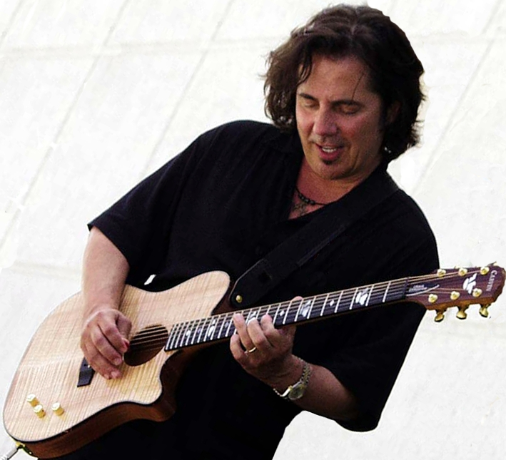
After four decades at the top of the charts ('70s, '80s, 90s, '00s) Craig started as band member, lead guitarist, principal songwriter, co-producer, and arranger with the legendary multi-platinum Jefferson Starship/Starship (1973-1990). Chaquico was instrumental in making the Jefferson Airplane & Jefferson Starship/Starship combination among the TOP 10 most successful acts in history, receiving 20 gold records. According to the RIAA this prestigious position is shared with Elvis Presley, Barbra Streisand, The Rolling Stones, Neil Diamond, The Beatles, Frank Sinatra, Elton John, and Bob Dylan among others.
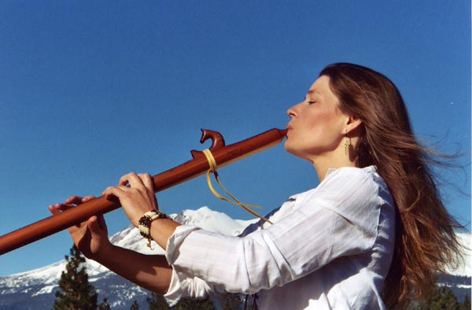
In the ‘90s and the ‘00s Chaquico then transformed into an award-winning solo smooth jazz artist and producer selling more than a million copies on his own. He was #1 on the Billboard Charts, Guitar Player Magazines’ Readers Poll #1 Best Pop Instrumental Guitarist and Jazz Is magazine included him in the top 100 most influential jazz guitar players of all time.
Gentle Thunder lives in Mt. Shasta, CA, yet enchants audiences worldwide with her distinctive sound and heart filled presence. Her music has been described as “a glorious musical journey that’s a sharing of deep spirit more than a mere performance” by Eric Alan- former JPR Music Director. Beyond Words, her third release (a trio album with Will Clipman & AmoChip Dabney) was GRAMMY nominated Best New Age Album in 2006. “These are powerful times we are living in and my intention is to support us all in remembering our authentic selves and to come home to our heart through the music I create and the stories I share,” said Gentle Thunder.
####
Photo of Craig Chaquico courtesy of Carvin Guitars/ Photo of Gentle Thunder by Nadine Aiello

